PL/SQL

1. Control Structures:

CREATE TABLE customers (

  customer_id NUMBER,

  name VARCHAR2(50),

  age NUMBER,

  balance NUMBER,

  interest_rate NUMBER,

  IsVIP VARCHAR2(5)

);

CREATE TABLE loans (

  loan_id NUMBER,

  customer_id NUMBER,

  due_date DATE

);

INSERT INTO customers VALUES (101, 'Ravi', 65, 12000, 7.5, 'FALSE');

INSERT INTO customers VALUES (102, 'Asha', 45, 8000, 6.0, 'FALSE');

INSERT INTO customers VALUES (103, 'Meena', 68, 15000, 6.8, 'FALSE');

COMMIT;

INSERT INTO loans VALUES (1, 101, SYSDATE + 15);  -- Due in 15 days

INSERT INTO loans VALUES (2, 102, SYSDATE + 40);  -- Due in 40 days

INSERT INTO loans VALUES (3, 103, SYSDATE + 5);   -- Due in 5 days

COMMIT;

SELECT * FROM customers;

SELECT * FROM loans;

BEGIN

  1. Discount for seniors

  FOR cust IN (SELECT customer_id, interest_rate FROM customers WHERE age > 60) LOOP

    UPDATE customers

    SET interest_rate = cust.interest_rate - 1

    WHERE customer_id = cust.customer_id;

  END LOOP;

  2. Promote VIPs

  FOR vip IN (SELECT customer_id FROM customers WHERE balance > 10000) LOOP

    UPDATE customers

    SET IsVIP = 'TRUE'

    WHERE customer_id = vip.customer_id;

  END LOOP;

  3. Print reminders

  FOR loan IN (

    SELECT customer_id, due_date FROM loans

    WHERE due_date BETWEEN SYSDATE AND SYSDATE + 30

  ) LOOP

    DBMS_OUTPUT.PUT_LINE(

      'Reminder: Customer ID ' || loan.customer_id ||

      ', your loan is due on ' || TO_CHAR(loan.due_date, 'DD-MON-YYYY')

    );

  END LOOP;

  COMMIT;

END;

SELECT name, interest_rate, IsVIP FROM customers;

SELECT c.name, c.IsVIP, c.interest_rate, l.loan_id, TO_CHAR(l.due_date, 'DD-MON-YYYY') AS due_date

FROM customers c

JOIN loans l ON c.customer_id = l.customer_id;

OUTPUT:

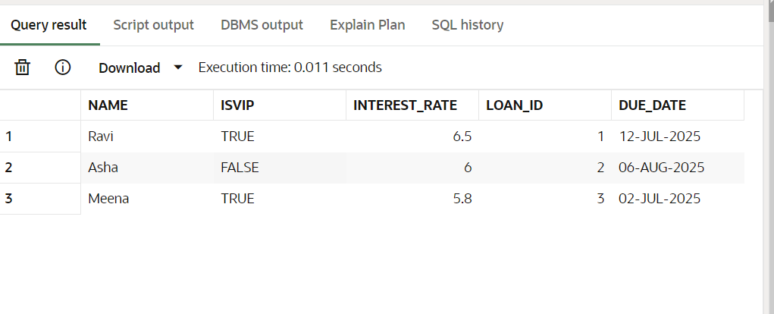

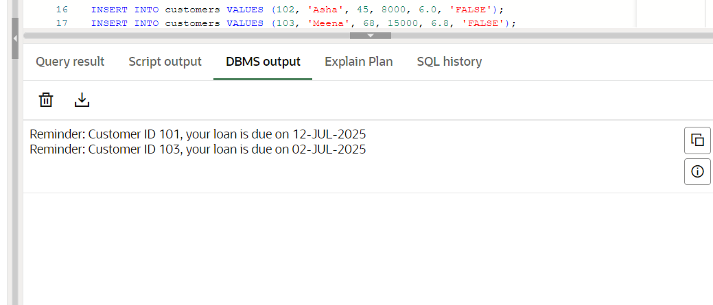

1. STORED PROCEDURE:

CREATE TABLE savings_accounts (

  account_id NUMBER,

  customer_name VARCHAR2(50),

  balance NUMBER

);

INSERT INTO savings_accounts VALUES (4001, 'Ravi', 12000);

INSERT INTO savings_accounts VALUES (4002, 'Meena', 18000);

INSERT INTO savings_accounts VALUES (4003, 'Keerthana', 9500);

COMMIT;

CREATE OR REPLACE PROCEDURE ProcessMonthlyInterest AS

BEGIN

  UPDATE savings_accounts

  SET balance = balance + (balance * 0.01);

  COMMIT;

END;

BEGIN

  ProcessMonthlyInterest;

END;

CREATE TABLE employees (

  employee_id NUMBER,

  department_id NUMBER,

  name VARCHAR2(50),

  salary NUMBER

);

INSERT INTO employees VALUES (201, 10, 'Anil', 40000);

INSERT INTO employees VALUES (202, 10, 'Kavya', 45000);

INSERT INTO employees VALUES (203, 20, 'Rahul', 50000);

COMMIT;

CREATE OR REPLACE PROCEDURE UpdateEmployeeBonus (

  p_department_id IN NUMBER,

  p_bonus_percent IN NUMBER

) AS

BEGIN

  UPDATE employees

  SET salary = salary + (salary * p_bonus_percent / 100)

  WHERE department_id = p_department_id;

  COMMIT;

END;

BEGIN

  UpdateEmployeeBonus(10, 10);  -- 10% bonus to Dept 10

END;

CREATE TABLE accounts (

  account_id NUMBER,

  customer_name VARCHAR2(50),

  balance NUMBER

);

INSERT INTO accounts VALUES (3001, 'Keerthana', 10000);

INSERT INTO accounts VALUES (3002, 'Asha', 7000);

COMMIT;

CREATE OR REPLACE PROCEDURE TransferFunds (

  p_from_acct IN NUMBER,

  p_to_acct IN NUMBER,

  p_amount IN NUMBER

) AS

  v_balance NUMBER;

BEGIN

  SELECT balance INTO v_balance

  FROM accounts

  WHERE account_id = p_from_acct;

  IF v_balance < p_amount THEN

    RAISE_APPLICATION_ERROR(-20001, 'Insufficient balance for transfer.');

  END IF;

  UPDATE accounts

  SET balance = balance - p_amount

  WHERE account_id = p_from_acct;

  UPDATE accounts

  SET balance = balance + p_amount

  WHERE account_id = p_to_acct;

  COMMIT;

END;

BEGIN

  TransferFunds(3001, 3002, 1500);  -- Transfer ₹1500

END;

SELECT * FROM savings_accounts;

SELECT * FROM employees;

SELECT * FROM accounts;

BEGIN

  DBMS_OUTPUT.PUT_LINE('Transfer complete!');

END;

/

OUTPUT:

